3D Shape Hunt (Indoor and Outdoor)

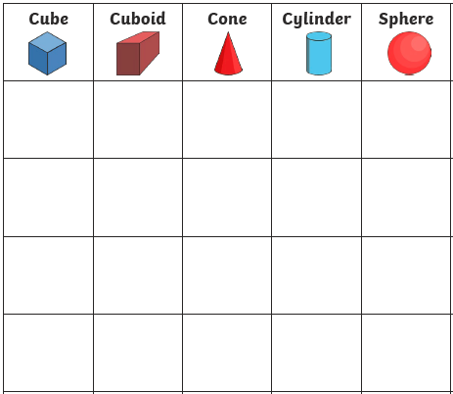
What shapes can you find in your house / garden? Record your findings in the table below. Draw the object and label it under the correct shape. Shapes to find: cube, cuboid, cone, cylinder and sphere.

