 |  | Spring Term 2024  Issue 4 27.03.24
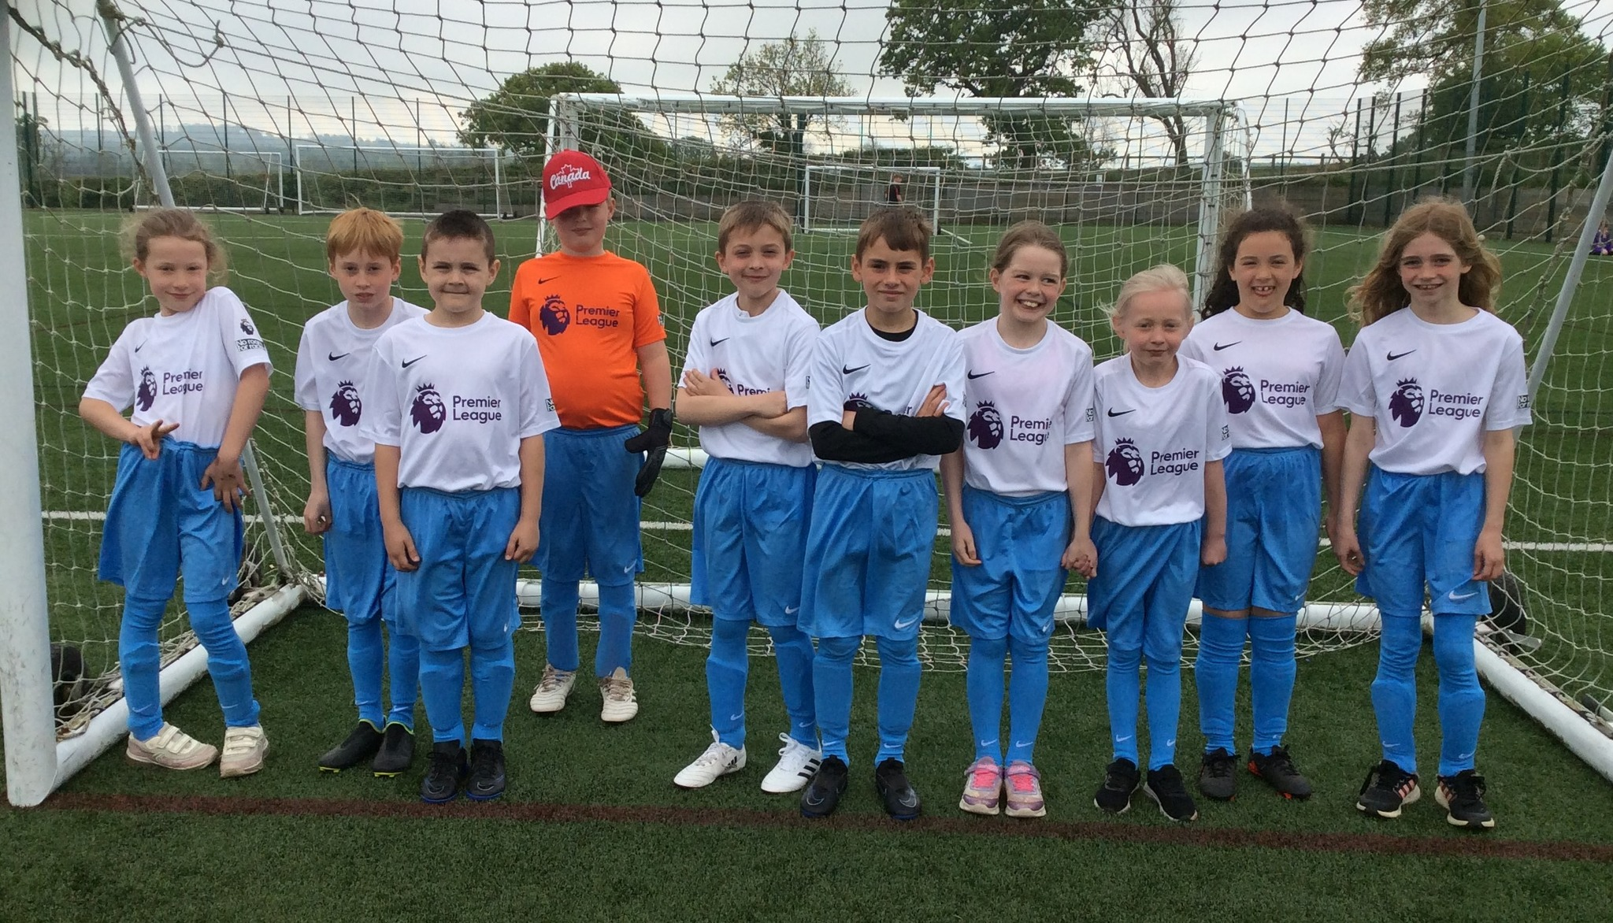 |  | NUFC Football Tournament  On Thursday 16th May, we took a team of Year 3 and 4 children to Alnwick, to take part in an inter-school football tournament. We were very impressed with the children's enthusiasm and resilience. Many of the children had not played competitive football before and really enjoyed the experience.
Pyjamarama Day  On Friday 17th May, the children enjoyed taking part in a special day celebrating books and reading.  We have donated £64 to ‘The Book Trust’ to help them continue their great work promoting a love of reading amongst children in the UK.  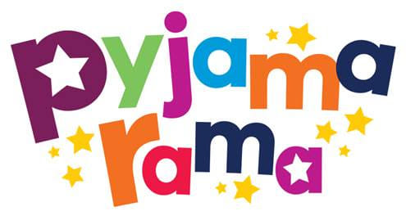 | Newcastle Visit  Class 2, 3 and 4 had a very enjoyable and informative visit to Newcastle Reform Synagogue the morning of the 1st May. We were very proud of the children, who were able to share their knowledge of the Jewish faith well. They showed great respect and listened well.  In the afternoon, they travelled a short distance to the Centre of Life, where they were able to test out their science knowledge and problem-solving skills.  A fabulous day all round! | Dates for the Diary  3rd – 5th June  Class 4 Robinwood residential  4th June  Year 3 and 4, Football Tournament  6th June  Countryside Day (Wooler)  Class 2 and 3  10th June 1.15pm  KS2 Sports Day  11th June 1.15pm  Class 2 Sports Day  Wednesday 28th June  Life Path Day for Class 3  Monday 1st July  Reception, Class 2, 3 and 4 school visit to Bamburgh Castle and Beach School.  Wednesday 3rd July  Year 6 to visit DCHS  Thursday 4th July  Year 6 Beach School  Tuesday 9th July  Class 2 Farne Islands visit  Wednesday 10th July  Year 6 visit to DCHS  Sport focus  Thursday 11th July 2.00pm  Year 6 Performance  Tuesday 16th July  Sponsored walk  Friday 19th July  Break up for summer.
Rugby
We have been very impressed with the children’s rugby skills this half term. They have made great progress. Our thanks to Dougie (their coach) for his hard work and commitment!



DCHS
Our Year 6 children met with Year 7 staff from the Duchess’s Community High School on the 23rd May. They had the opportunity to ask questions and hear about the exciting things that they will be able to do when they move there in September

Belford Arts Festival
Children from across our school have been invited to sing in the marketplace, Belford, on Sunday 14th July at 2pm.
This is the weekend of the Belford Arts Festival. Please support this lovely community event.

