Measuring lesson- 1

Hello,

If we were in school we would be moving onto the unit ‘measuring weight’. This is something that can be taught at home if you have a set of weighing scales of access to a computer that can open up a presentation.

- In year 1, children look at balance scales and compare the weight of objects. Which object is heavier and how do you know? What would the scales do if the weight of the objects were the same? Begin to look at packaging of food and the unit of measurement that is used (grams and kilograms). We use grams to measure light objects and kg when objects are heavy.
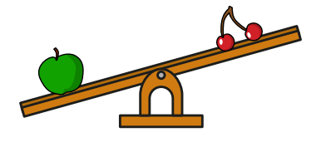

https://whiterosemaths.com/homelearning/year-1/

Here is a link to a weight presentation that gives examples of balance scales, along with a worksheet that will check your child understands. I do not expect you to print the sheet off but you could just ask your child what the answer would be.

- In year 2, children begin to read the increments on a set of weighing scales. Using weighing scales at home (manual or electronic) children can estimate the measurement of some light objects around the house, then check by weighing the object. They do not need to record anything, but just get used to reading the scales and working out the increments when counting in 10’s or 20’s etc… Can children get small object of different weights and say which they will think is heaviest/lightest, then check the weight using the scales?

I have made a worksheet with scales measuring in different increments. Please get your child to look at each one carefully and discuss the increments the scale is counting in. They may need some support to do this as it’s tricky. Not all scales are counting in the same increment.

Year 2 and a challenge for Year 1

What weights do these scales show? Discuss the increments of each set of scales.
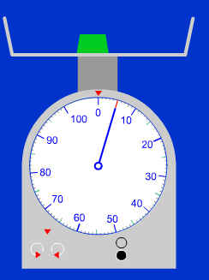
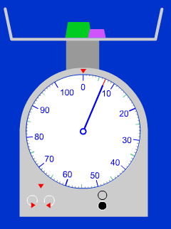
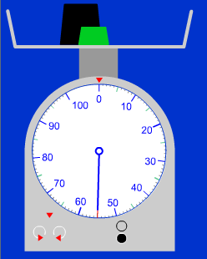

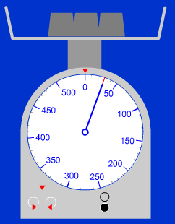
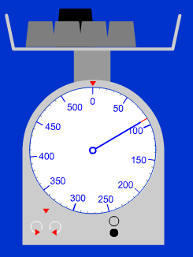
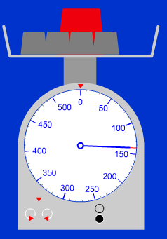

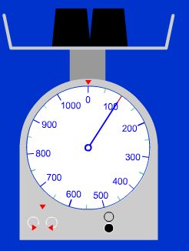
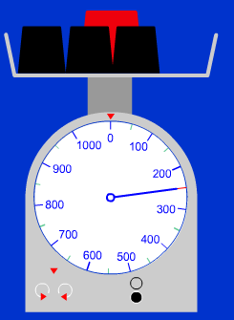
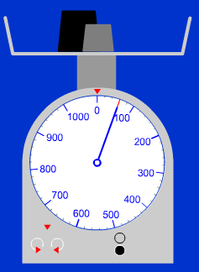

Year 1 - Question to discuss with your child.
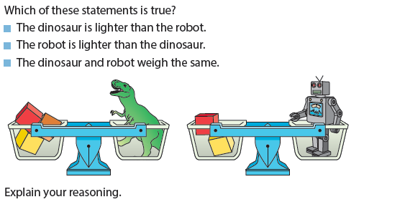
Explain!

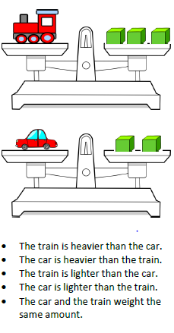
True or False?

Year 2 – Question to discuss with your child.

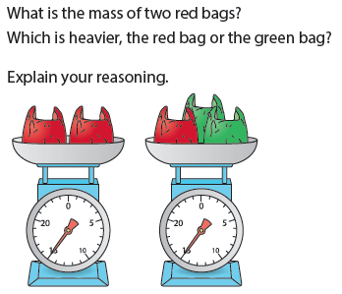
Explain!

For Year 2 children who are working at greater depth.

Solve it!

The picture above shows four equal weights on one side of the scale and an apple on the other side.
- What can you say that is true about the apple and the weights?
- If the apple weighs 20g, how heavy must one weight be?
- If the apple weighed 80g, how heavy would one weight be?
- If the apple was a giant one and weighed 800g and the weights were each 200g, what would the scale look like? How do you know?

