Grace Darling
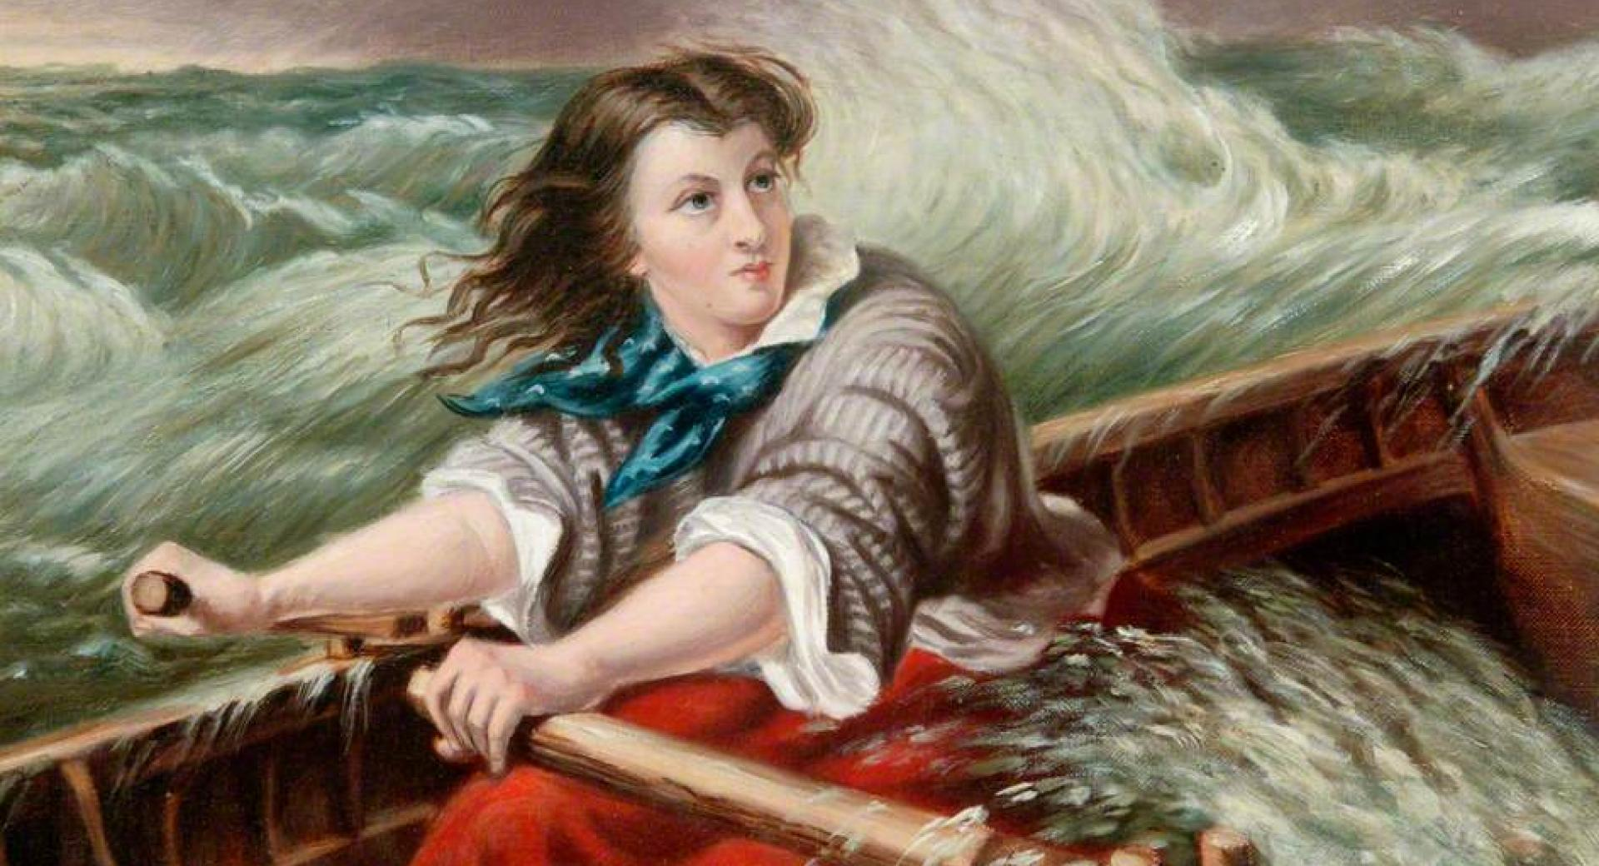

Our topic after Easter is about a local heroine, Grace Darling. In this topic, children will learn about who she was, why we remember her and about life in the early 1800s. Our plan was to take children to the Farne Islands in May and also visit the Grace Darling Museum (fingers crossed this might be something we can do in the Summer term).

Each week I will set a little task based around Grace Darling, just so the children aren’t missing this part of the History Curriculum.

Task 1
With your child, discuss this picture. Can your child come up with their own questions about the picture?

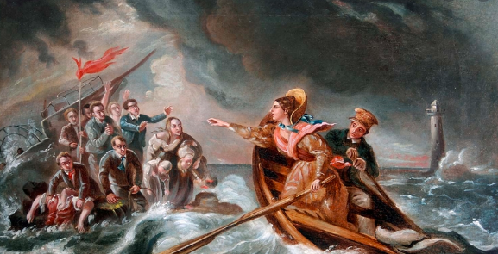

Prompts for parents:
- What do you think this picture is showing?
- Where are they?
- When do you think this picture is from?
- What do you see in the background?
- Who is the woman and man in the boat?
- What is going on with the other people in the picture?

After discussing the picture and questioning the children, go through the presentation with your child and learn many facts about Grace Darling.

